1982 KING AIR F90 N11WN LA-177

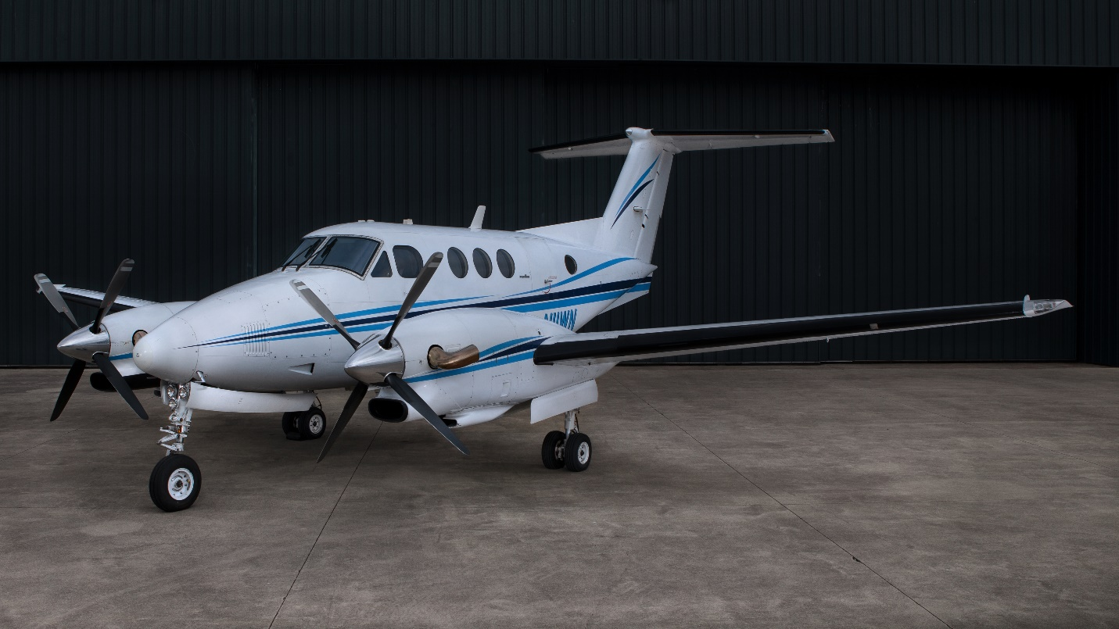
9775 TOTAL TIME
2920 SINCE ENGINE OH
No Damage History
2016 INTERIOR
ADSB COMPLIANT
XM WEATHER

AVIONICS
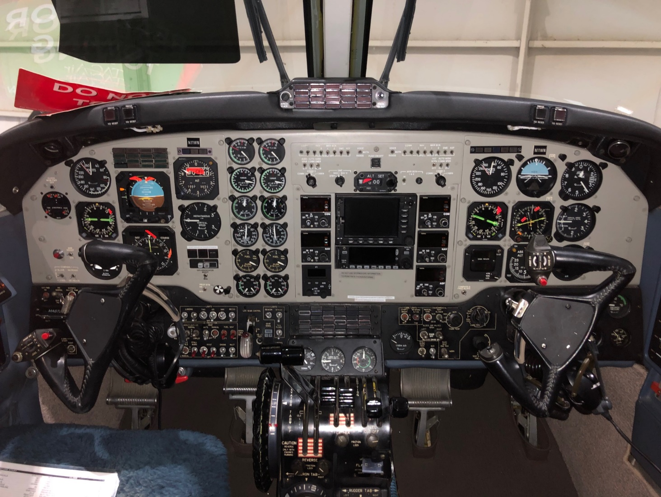
ADF: Collins ADF-60A
Autopilot: Sperry SPZ-200A IFCS
Avionics Package: Sperry SPZ-200 IFCS/Pro Line
Communication Radios: Dual Collins VHF-22A
DME: Collins DME-40
Flight Director: Sperry SPI-400 IFCS
GPS: King KLN-94 color
HSI: Dual Collins
Navigation Radios: Dual Collins VIR-30A
Radar Altimeter: Collins ALT-50
RMI: Dual Collins
Stormscope: BFGoodrich WX-500
TAWS: Honeywell IHAS-8000
Transponder: Dual Garmin GTX335R with ADSB
Weather Radar: Bendix/King RDR-2100vp

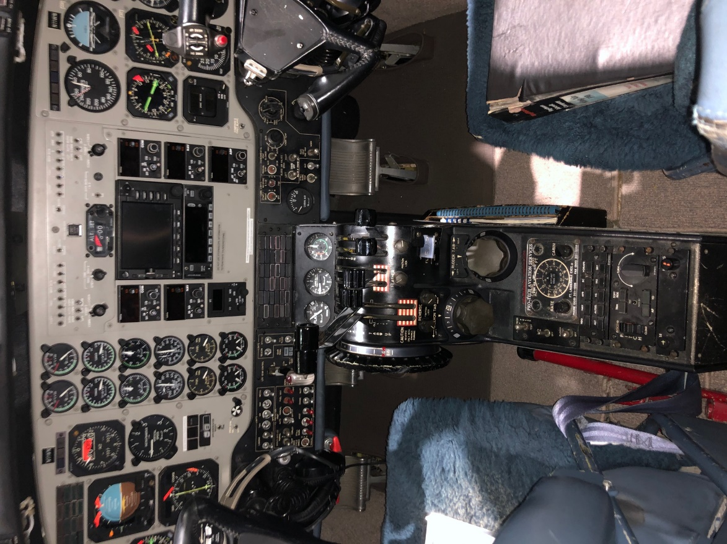
ADDITIONAL EQUIPMENT
Cockpit: Honeywell IHAS-8000, dual Collins audio panels, dual Collins marker beacons, King KMD-850 multi-function display, weather display, Shadin ADC-2000 air data computer, dual electric trims, standard interphone, Davtron clock/timer, Aerox DD725 crew masks, Upgraded to electric flushing lavatory from the bucket style.
Crew Accessories: Rosen sunvisors
Equipment: American Aviation ram air induction system, Frakes exhaust stacks, lead acid battery conversion

INTERIOR
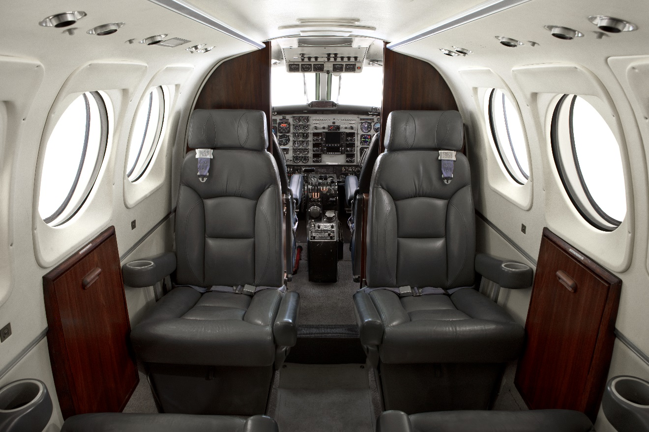
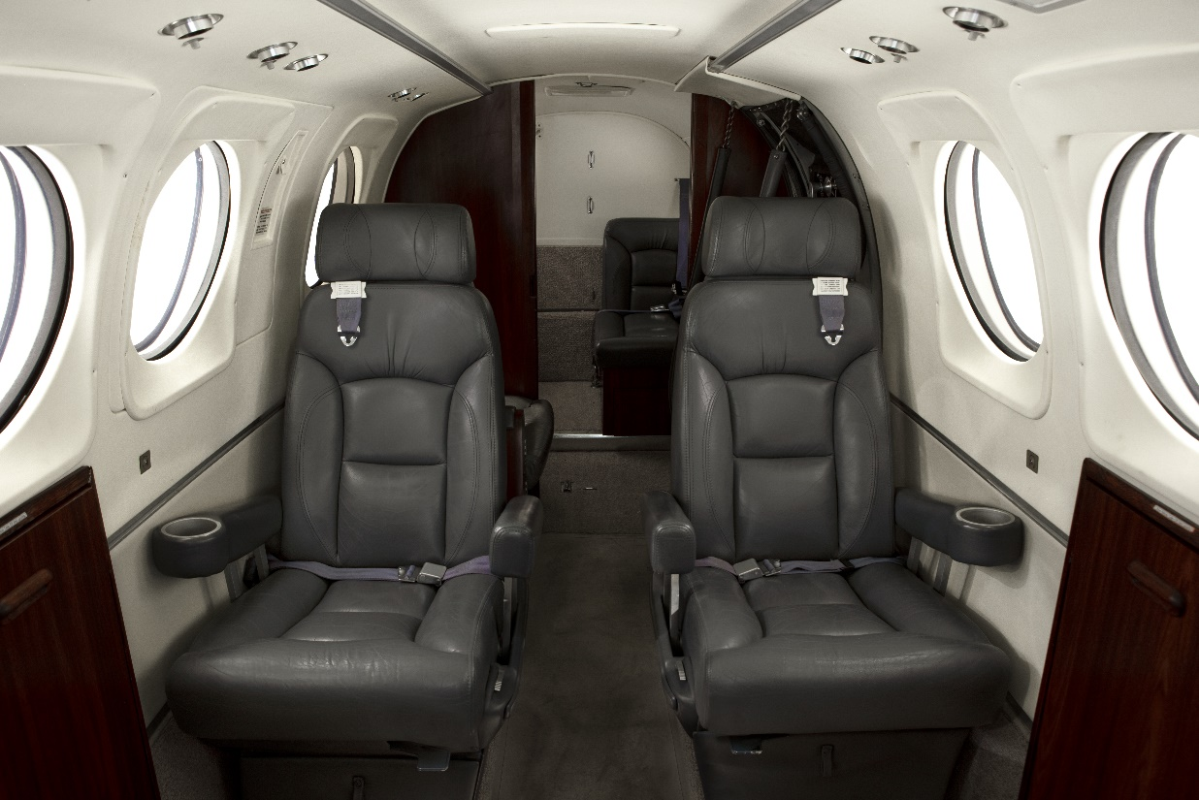

Four place interior with a side facing belted “potty” seat and a rear belted jump seat. Interior was refurbished in 2014 and is in excellent condition.
EXTERIOR
Uvalde exterior in 2006 - white w/dark & light blue trim
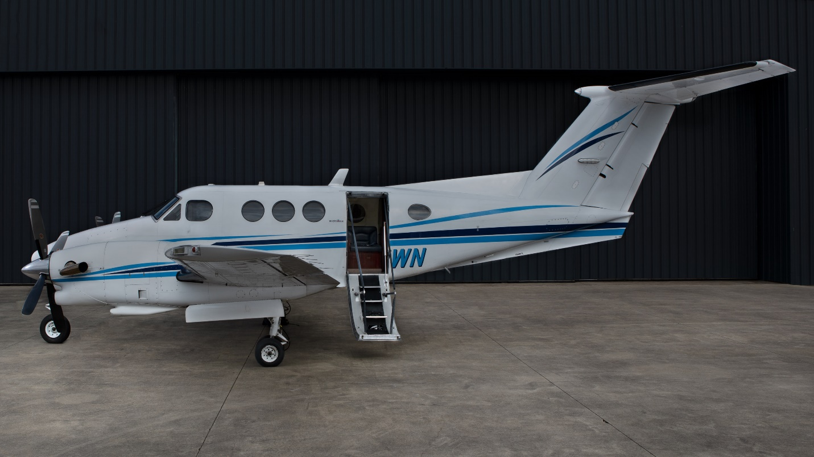

FOR MORE INFORMATION CONTACT:

TIM PALMA
TIM@SOLUTIONSAIRCRAFT.COM
317-414-1044

3879 N. Aviation Way, Greenfield, IN 46140

