1978 KING AIR B100 BE-52

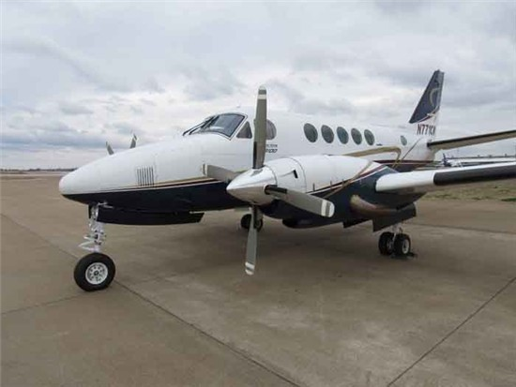
8 Seats
Airframe
Total Time: 8,667.8
Landings: 7,041
Engine TPE331-10AV-511B
#1 ENGINE: 8,319.7 Hours SNEW, 3,284 Hours SOH
#2 ENGINE: 8,444.4 Hours SNEW, 3,458 Hours SOH

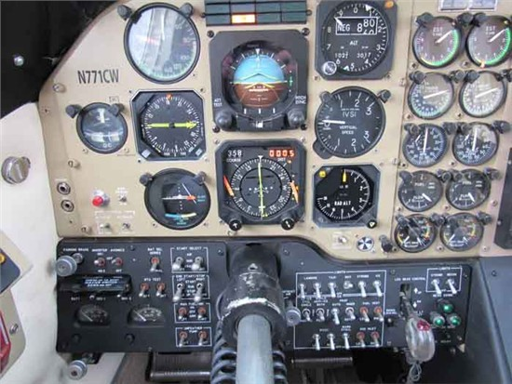
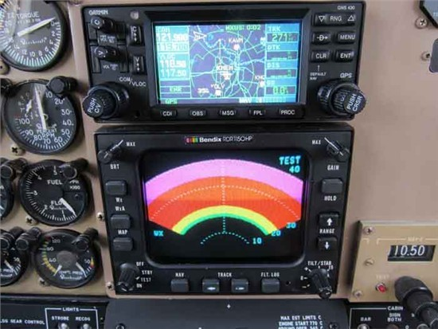

Avionics
Collins ADF-60A
Sperry Encoding & Alerting Altimeter
Sperry SPZ-200 IFCS Autopilot & FD
Dual Collins VHF-20A; Garmin GNS-430W Comms
Collins; Sperry C-14-43 Compass
Collins DME
Garmin GNS-430W GPS
Collins Co-Pilot; Sperry HIS
Northstar M3 w/GPS LRN
Dual Collins VIR-30AGM; Garmin GNS-430 Navs
Collins ALT-50A Radar Altimeter
Collins RMI-30/36/DBI-36
Bendix KGP-560 EGPWS
Ryan ATS-9900B TCAD
Bendix RDR-1150HP Color Weather Radar
Dual Collins TDR-90 Transponders
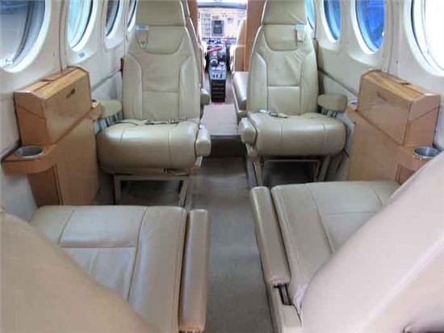
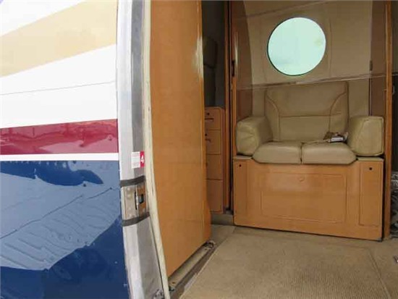

FOR MORE INFORMATION CONTACT:

TIM PALMA
TIM@SOLUTIONSAIRCRAFT.COM
317-414-1044

3879 N. Aviation Way, Greenfield, IN 46140

